Foundation Program for Learning English Language
​
This is a one-year full time programme designed to prepare international students for successful entrance to the College, by enhancing their language proficiency. The programme focuses on developing the students' English language skills in listening, speaking, reading, and writing, as well as building their
academic language and communication skills required for successful study in the College. The academic year is divided into two semesters each one of which is thirteen weeks in duration. The programme is accredited by the CYQAA.

The programme’s objectives are to ensure that students will:
1. Attain proficiency in all language skills: listening, speaking, reading, and writing.
2. Develop academic vocabulary and language necessary for Higher Education studies.
3. Enhance communication skills for academic and social interactions.
4. Gain confidence in participating in class discussions and debates and presenting academic topics.
5. Improve critical thinking and analytical skills through reading and writing tasks.

Course Distribution by Semester:

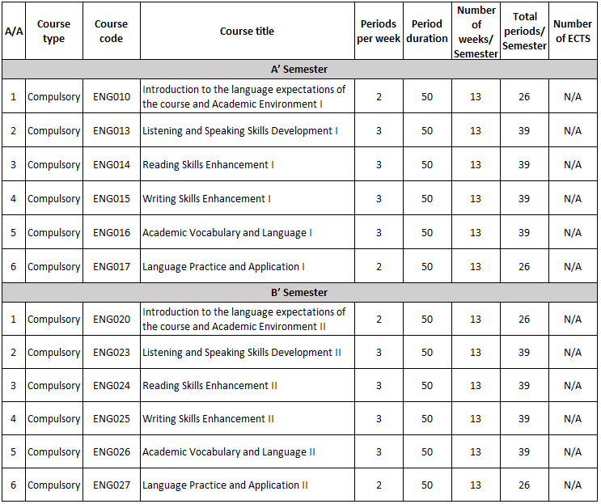

Teaching Staff in the Programme:

Erasmia Dede

Studied English Language and Literature and obtained a Bachelor of Arts in 2008 from the National and Kapodistrian University of Athens. Her degree is specialised in Literature and Culture, also including teaching methodology, applied linguistics and class management among other courses. In 2020, she obtained a Master’s Degree in Teaching Greek as a Second Language from the University of Nicosia. During her thesis she collaborated with schools from the UK, Australia, Mexico, Spain, Argentina and the USA. With a total professional experience of 16 years, the lecturer has been committed to teaching both languages, English and Greek, as second ones to speakers of other languages. She is experienced in private tutoring, group classes, face-to-face and online ones. Her vocational experience began with employment in private foreign languages academies. She has been a lecturer at the College of Tourism and Hotel Management since 2019, and a lecturer at University of Nicosia since 2020.

